Where Dreams Begin: A Midwest Tradition Comes to Arizona
Tiny Town didn't start with a blueprint—it started with a memory.
Our family moved to Arizona from Chicago, where we grew up visiting "Safety Town," a miniature village where kids pedaled three-wheel bikes through tiny streets, learning the rules of the road and how to cross intersections safely. It was magical. It was purposeful. And Arizona didn't have anything like it.
We wanted to change that.

The Spark: A World Record and a Backyard Discovery (2023)
In 2023, our oldest son had a wild idea: break the world record for the most artificial Christmas trees in a holiday display—about 100 trees. Just for fun.
So we hit the streets during bulk trash nights in Gilbert and Mesa, rescuing discarded Christmas trees destined for the landfill. After collecting about 20 trees, we arranged them around a small playhouse in our backyard.
And something magical happened.
The playhouse looked like a cottage in an enchanted forest. We stared at it, and a new vision began to form—what if we built an entire town? (Side Note: We have not broken the record as of yet!)

Tiny Town is Born: November 2024
In late 2024, as we collected playhouses for our Safety Town project, our oldest son had another idea: "What if we decorate these houses with Christmas lights?"
That's when Tiny Town was born.
So we went to work. Throughout November 2024, we scoured the area for every little playhouse we could find and designed a layout… 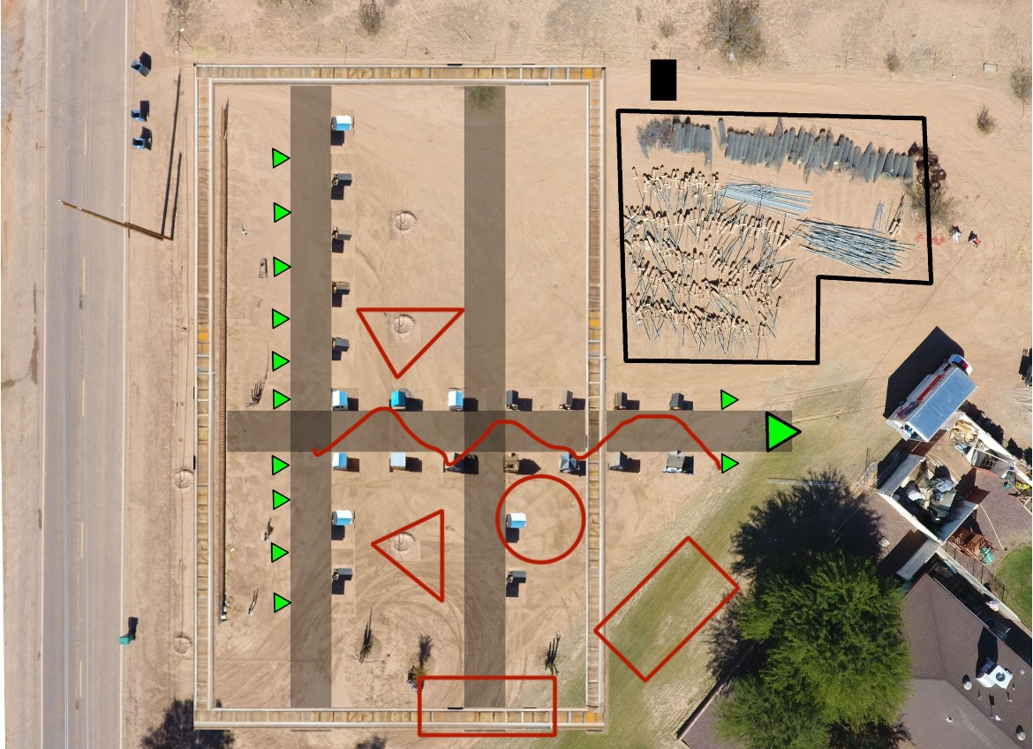designed the layout
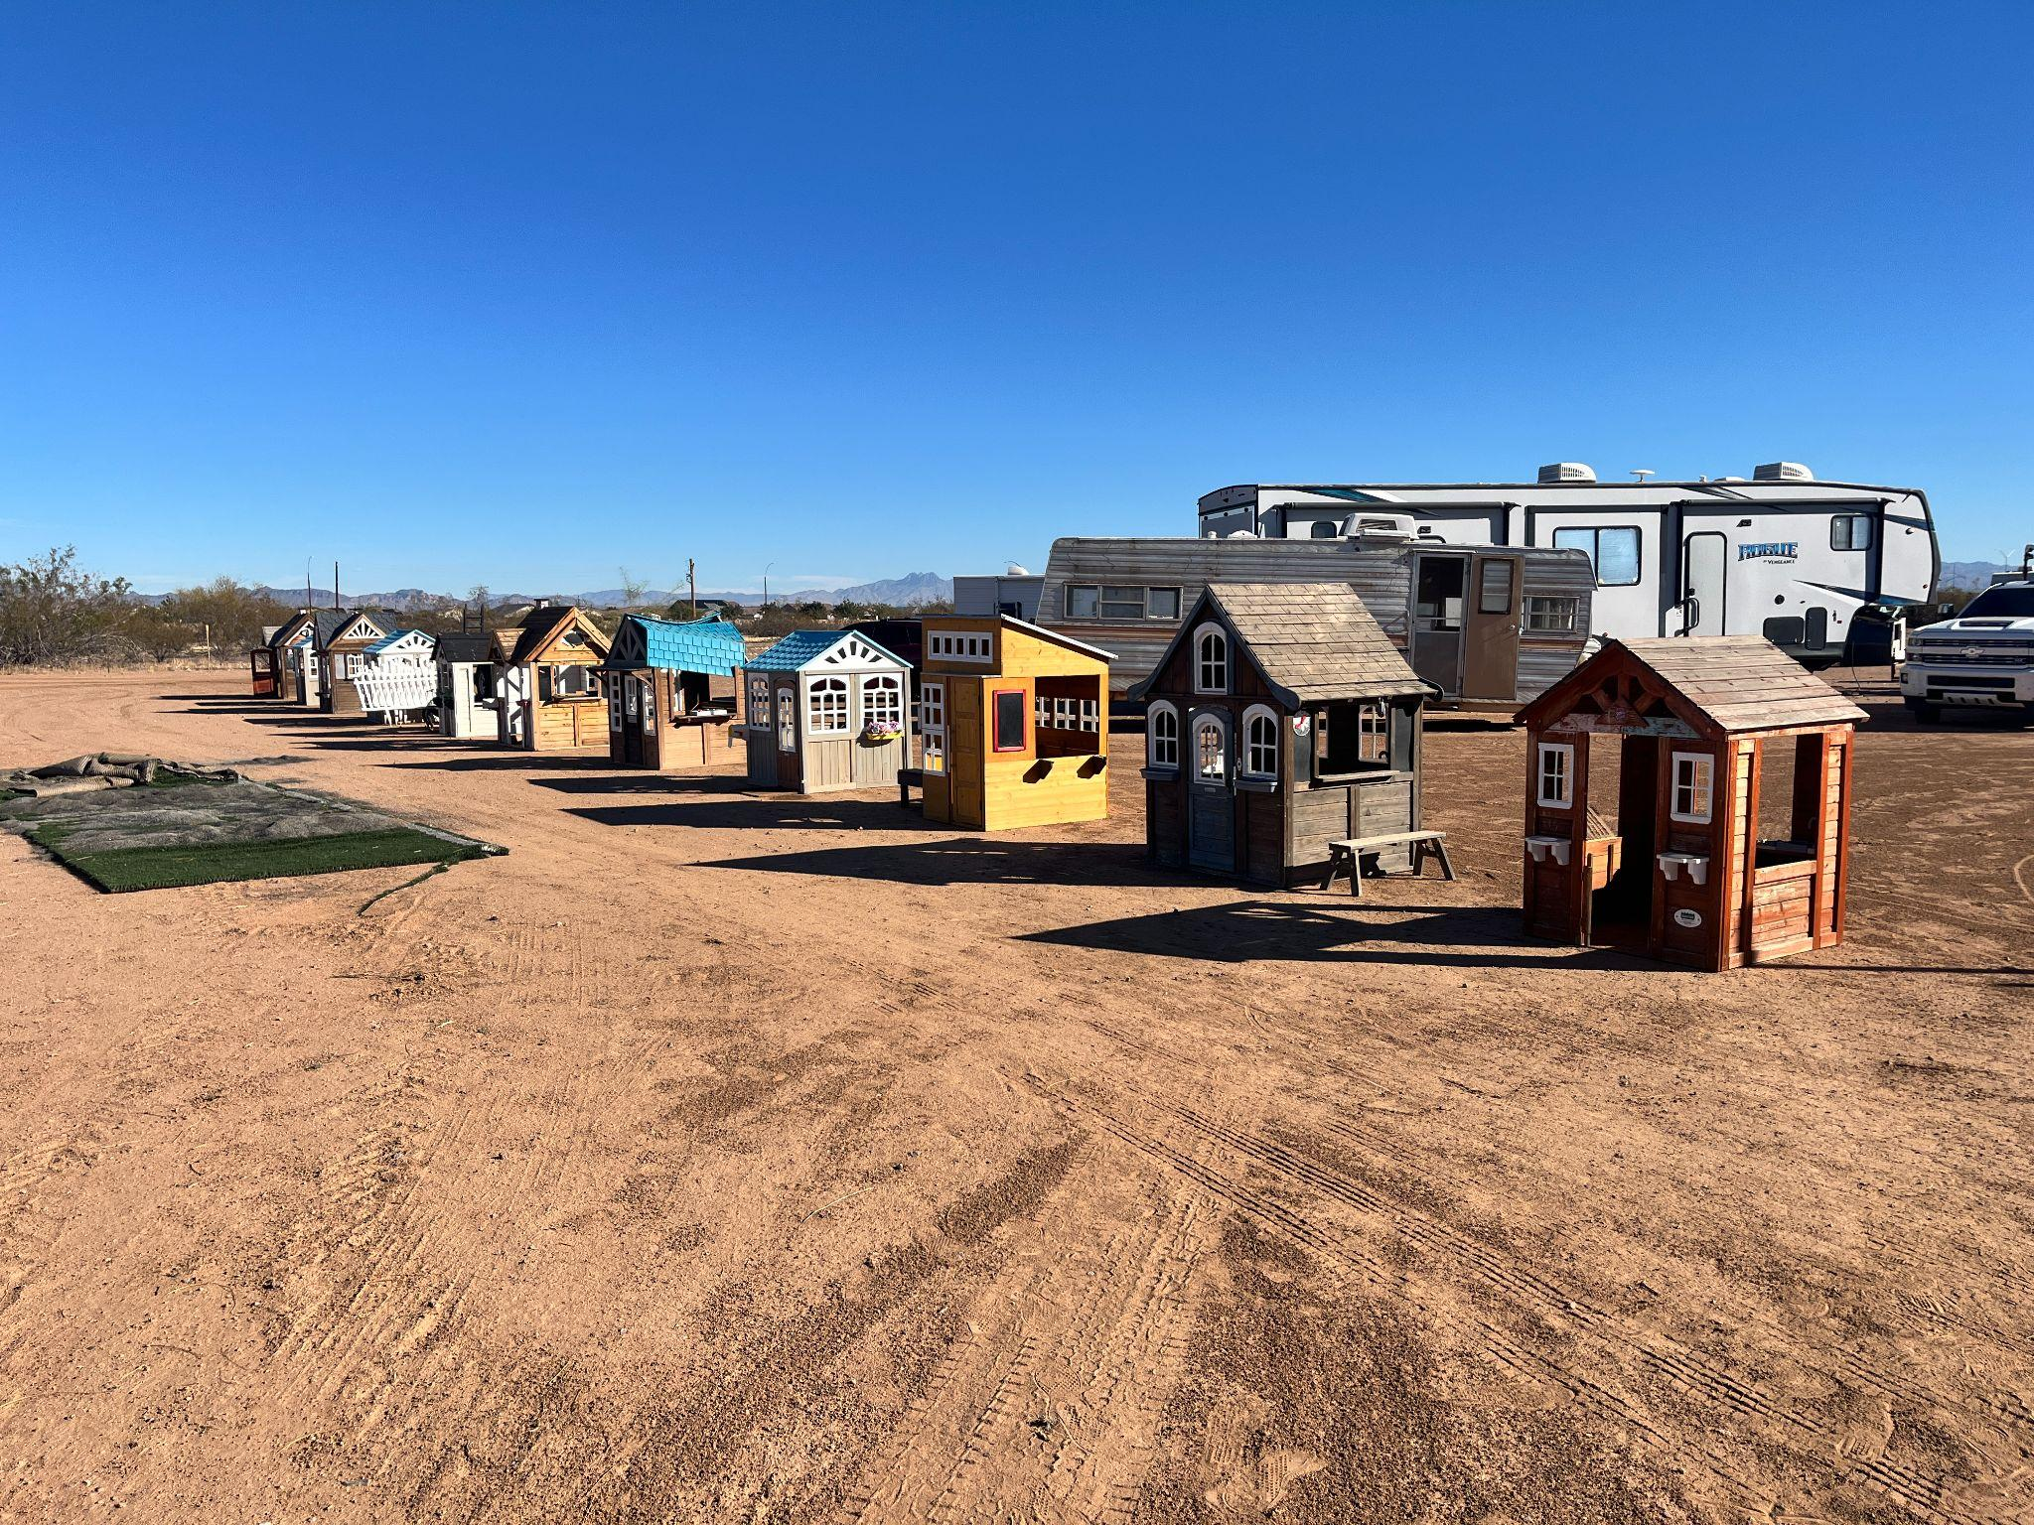First houses start to arrive and are placed
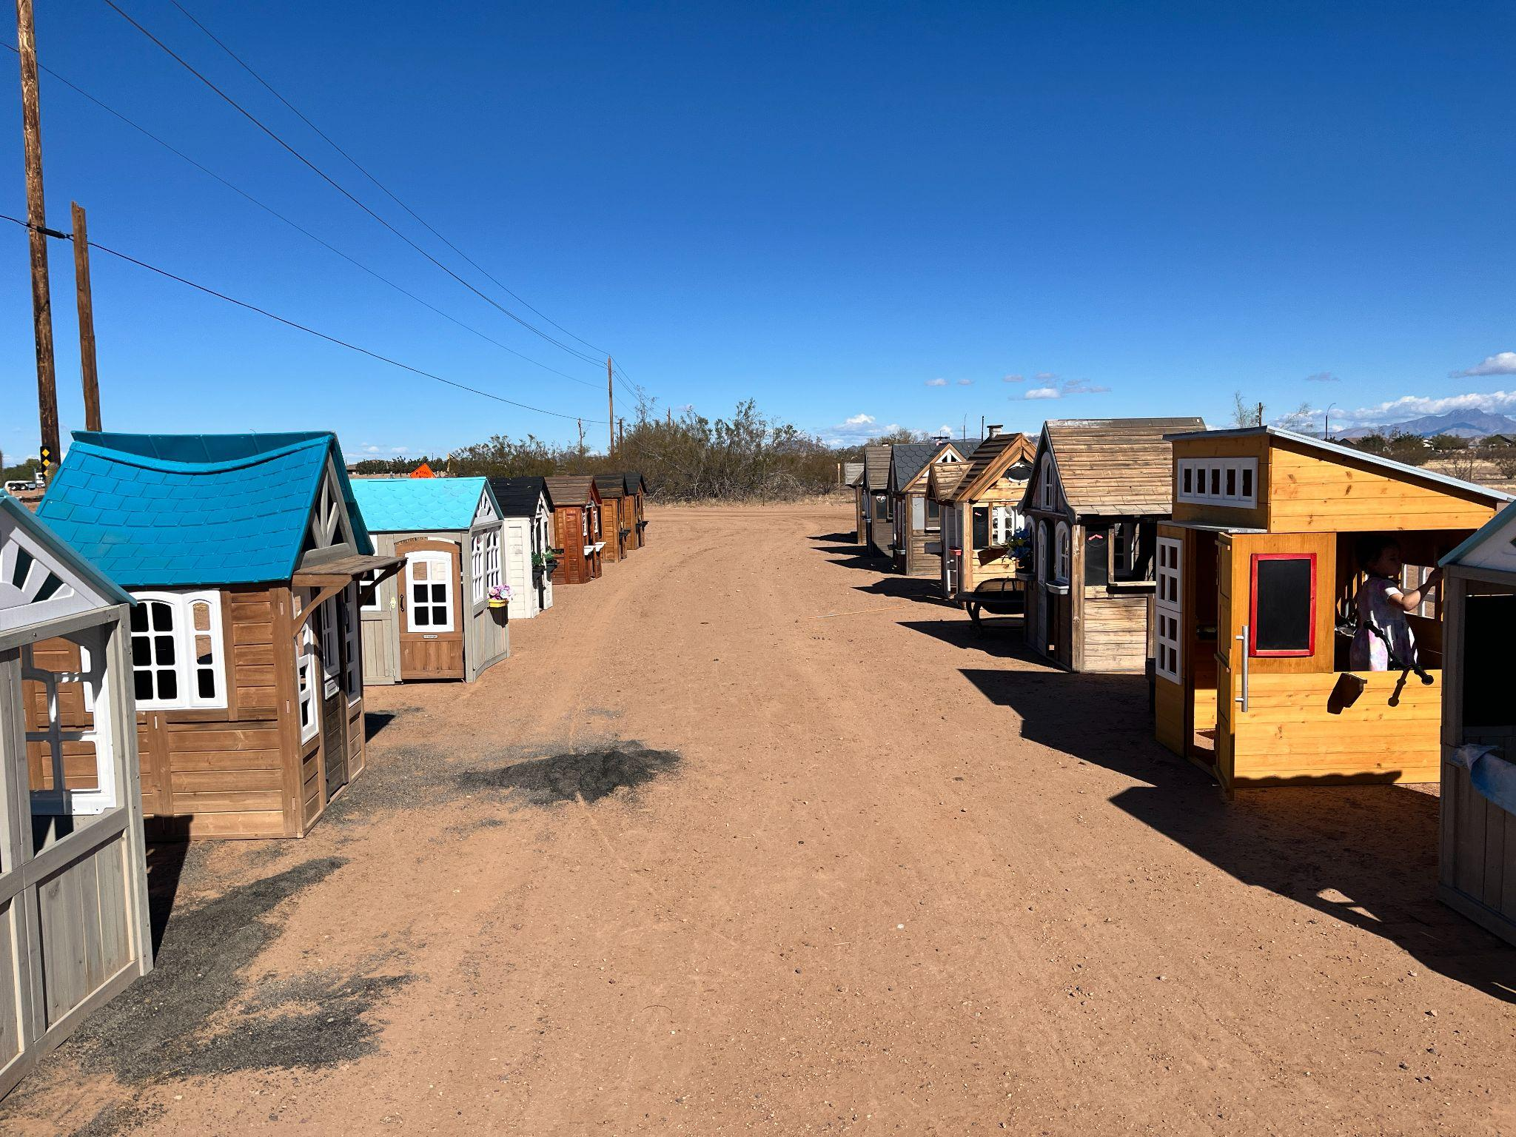
Layed the houses house to look like an old west town, but didnt like the dirt

Spaced out the houses a little diffrently
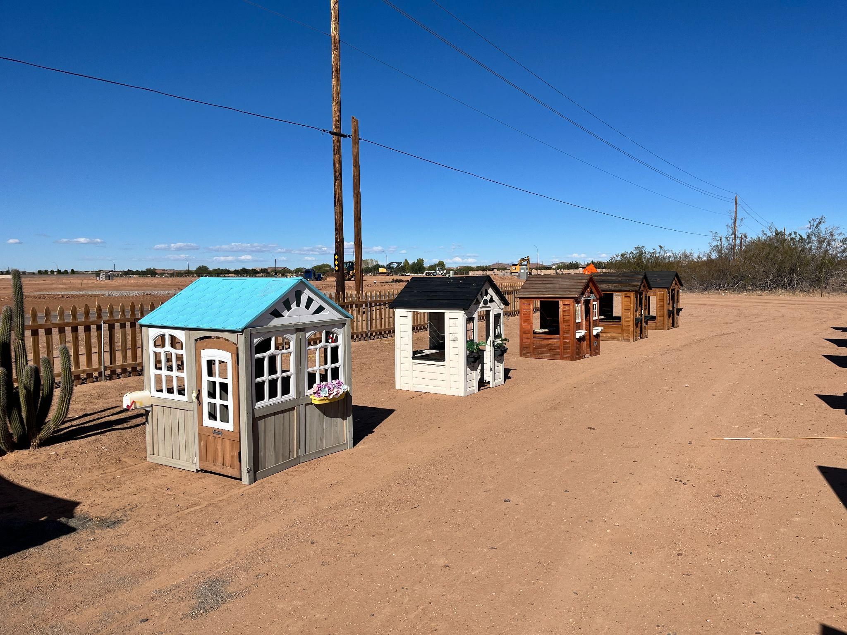
New layout spacing is discovered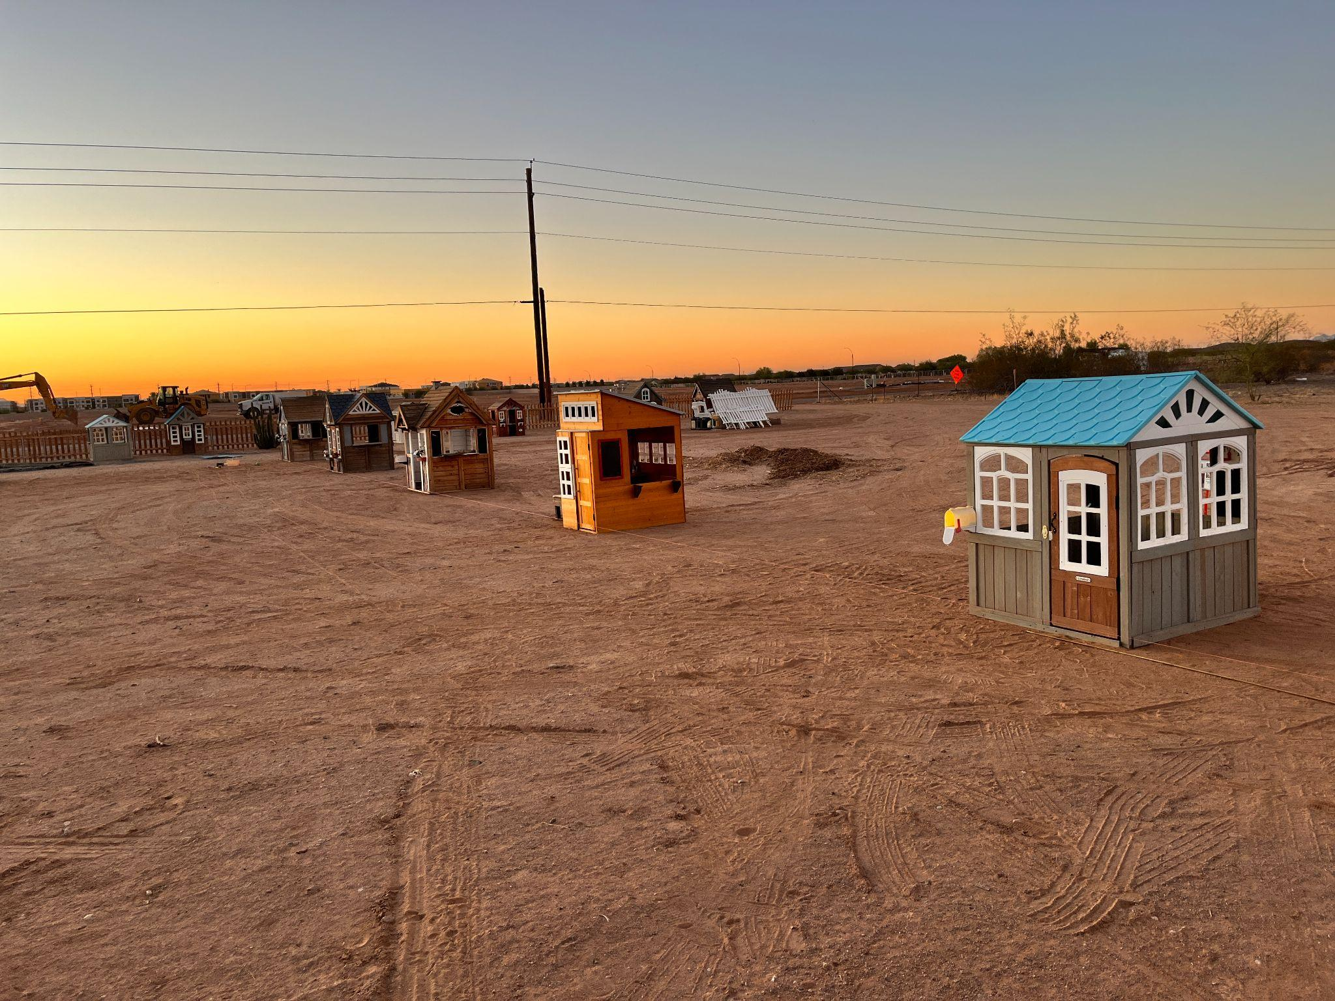
Thoght it would look better with fake black top instead of dirt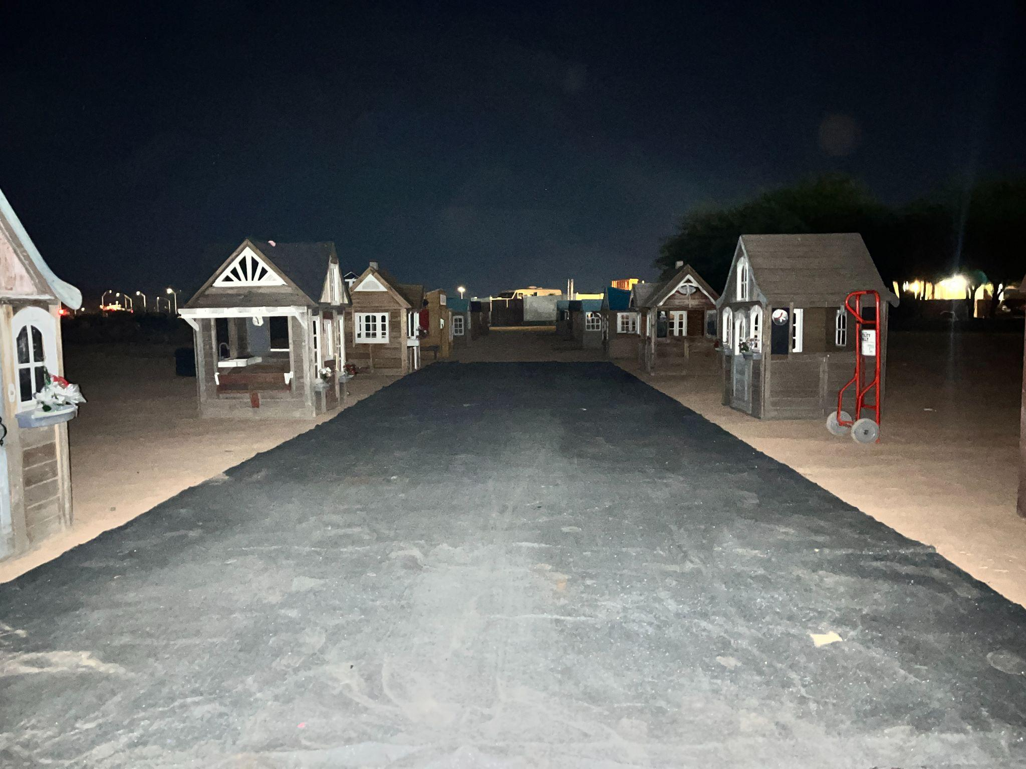

playing with spacing and fence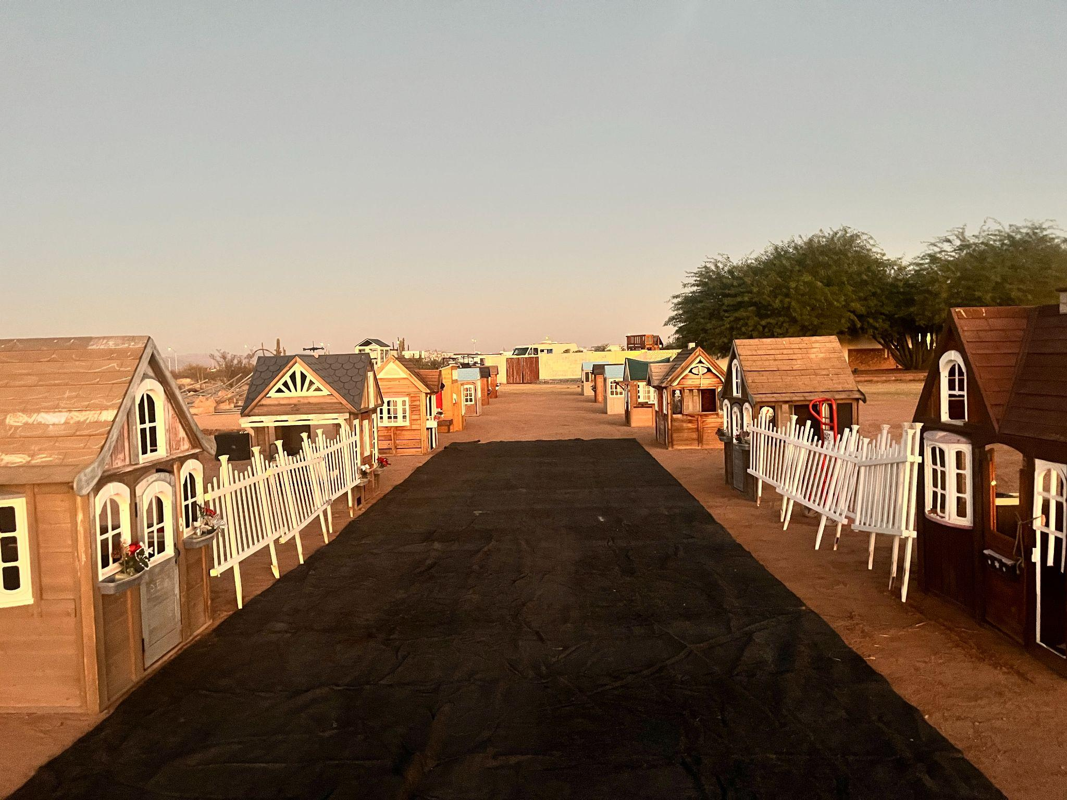
30ft tree begines to shape up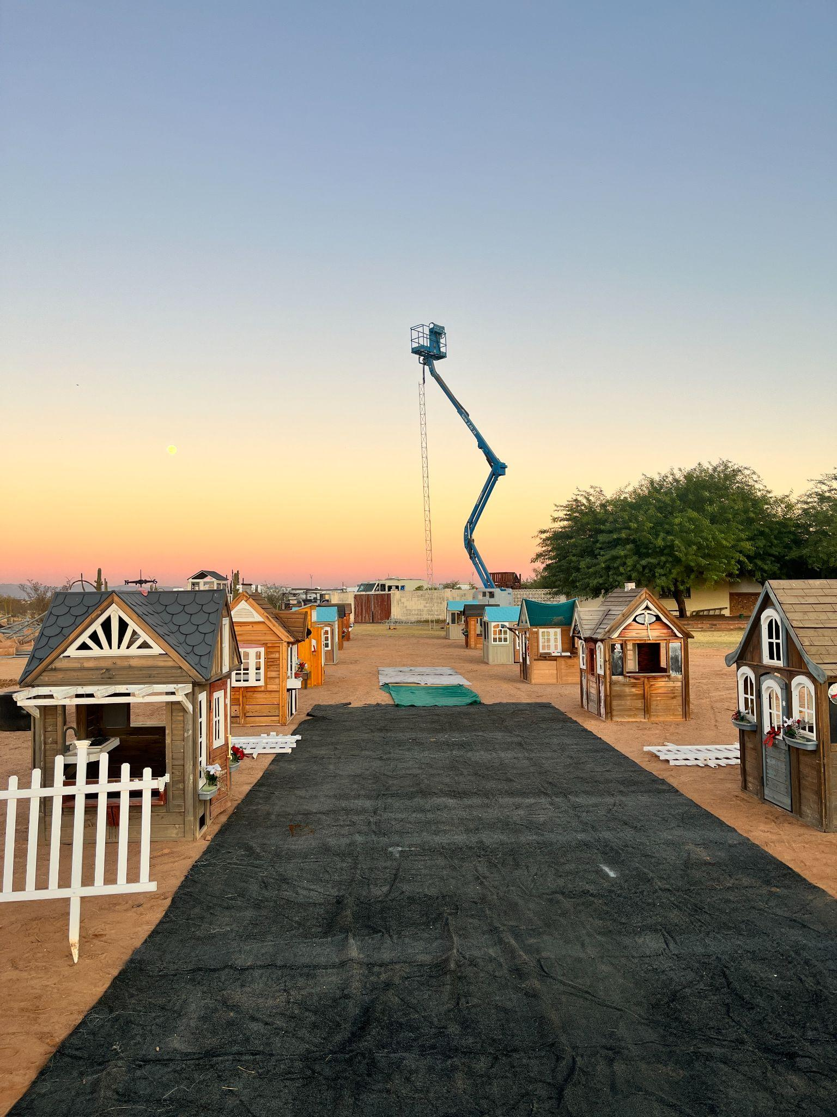
still working on spacing trying to design a forced perspective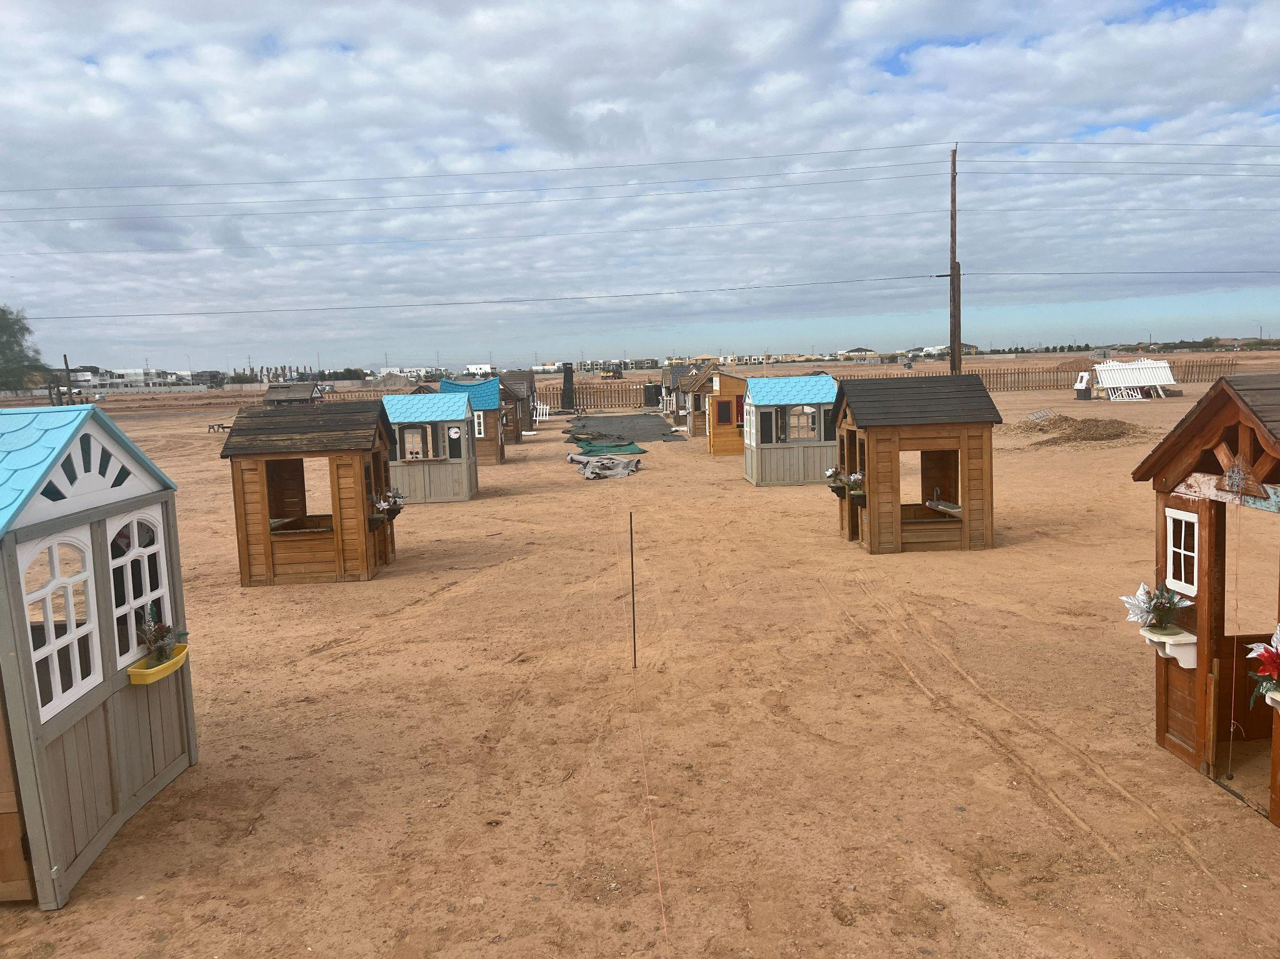
did away with the black turf and got a black vynil tarp instead moving blankets were laid down as an underlayment of the tarp to give it a better feel when walking on it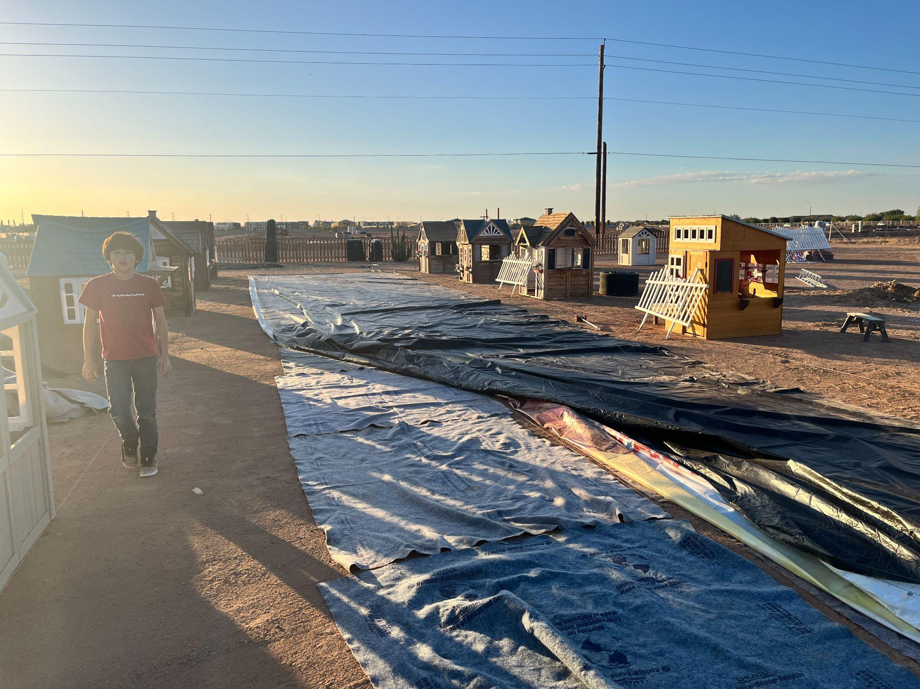
Tarp is looking nice 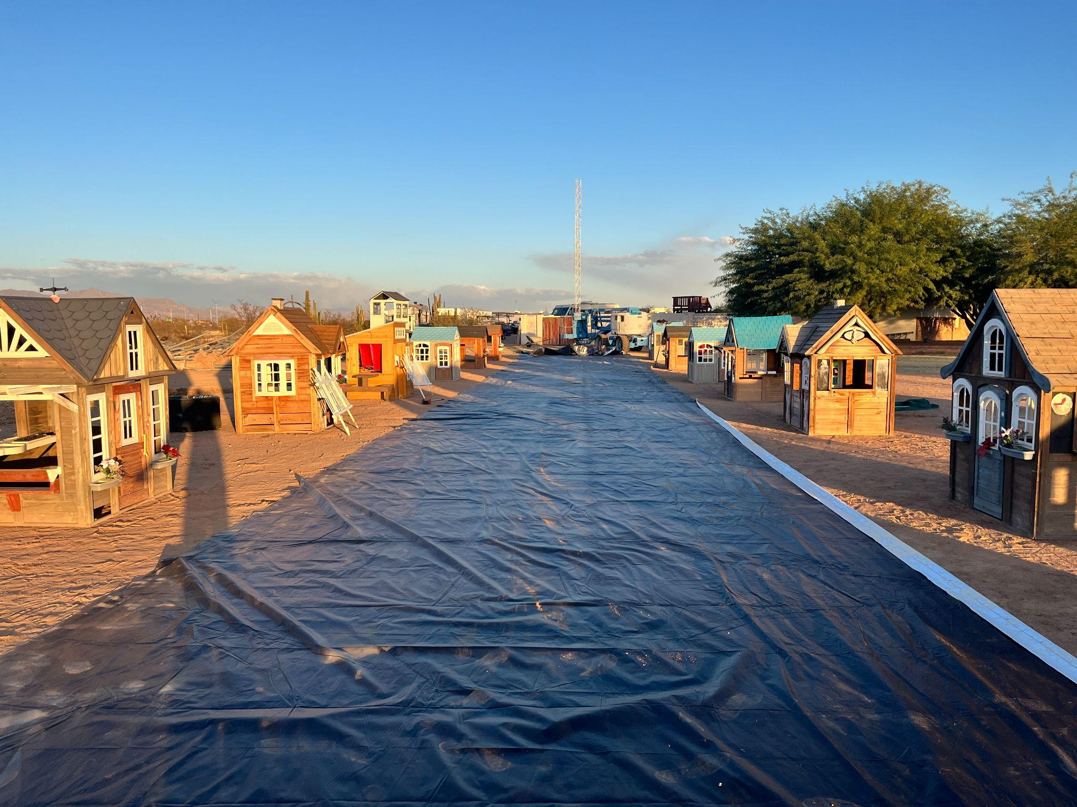miniture street lamp post arrived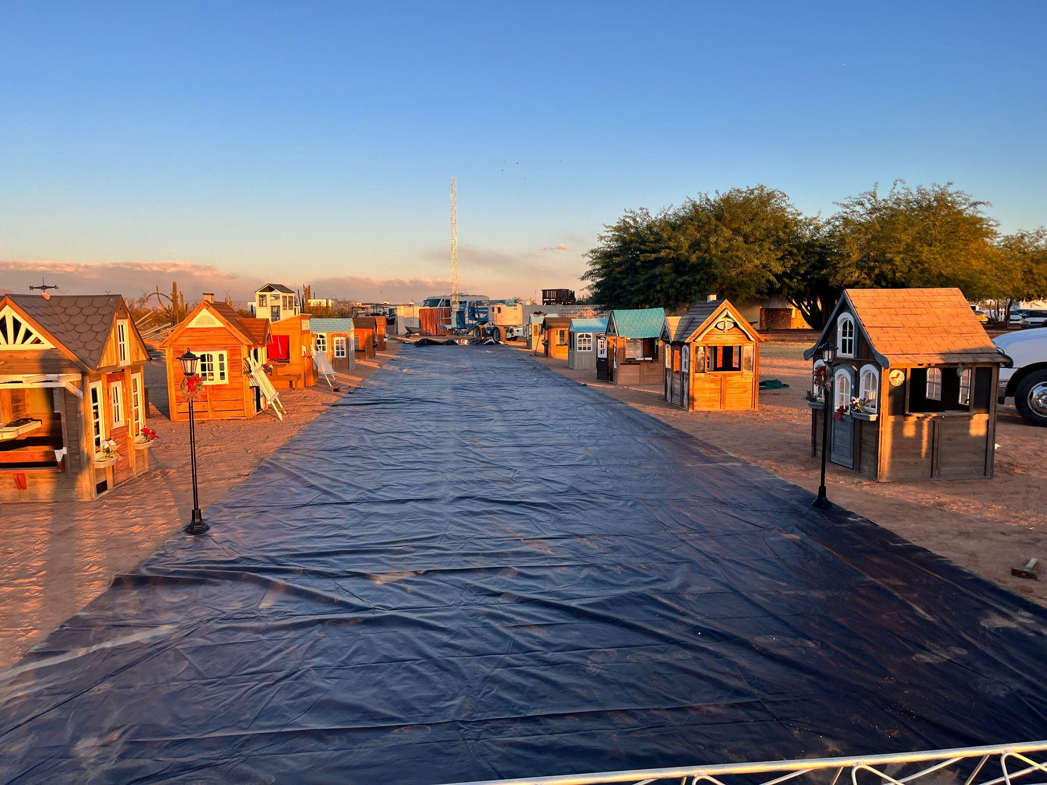
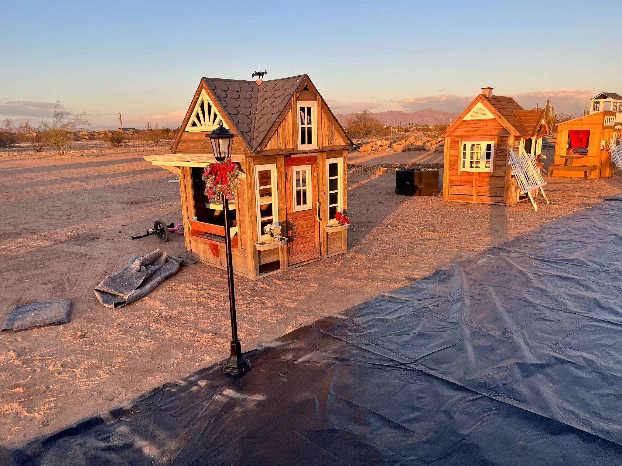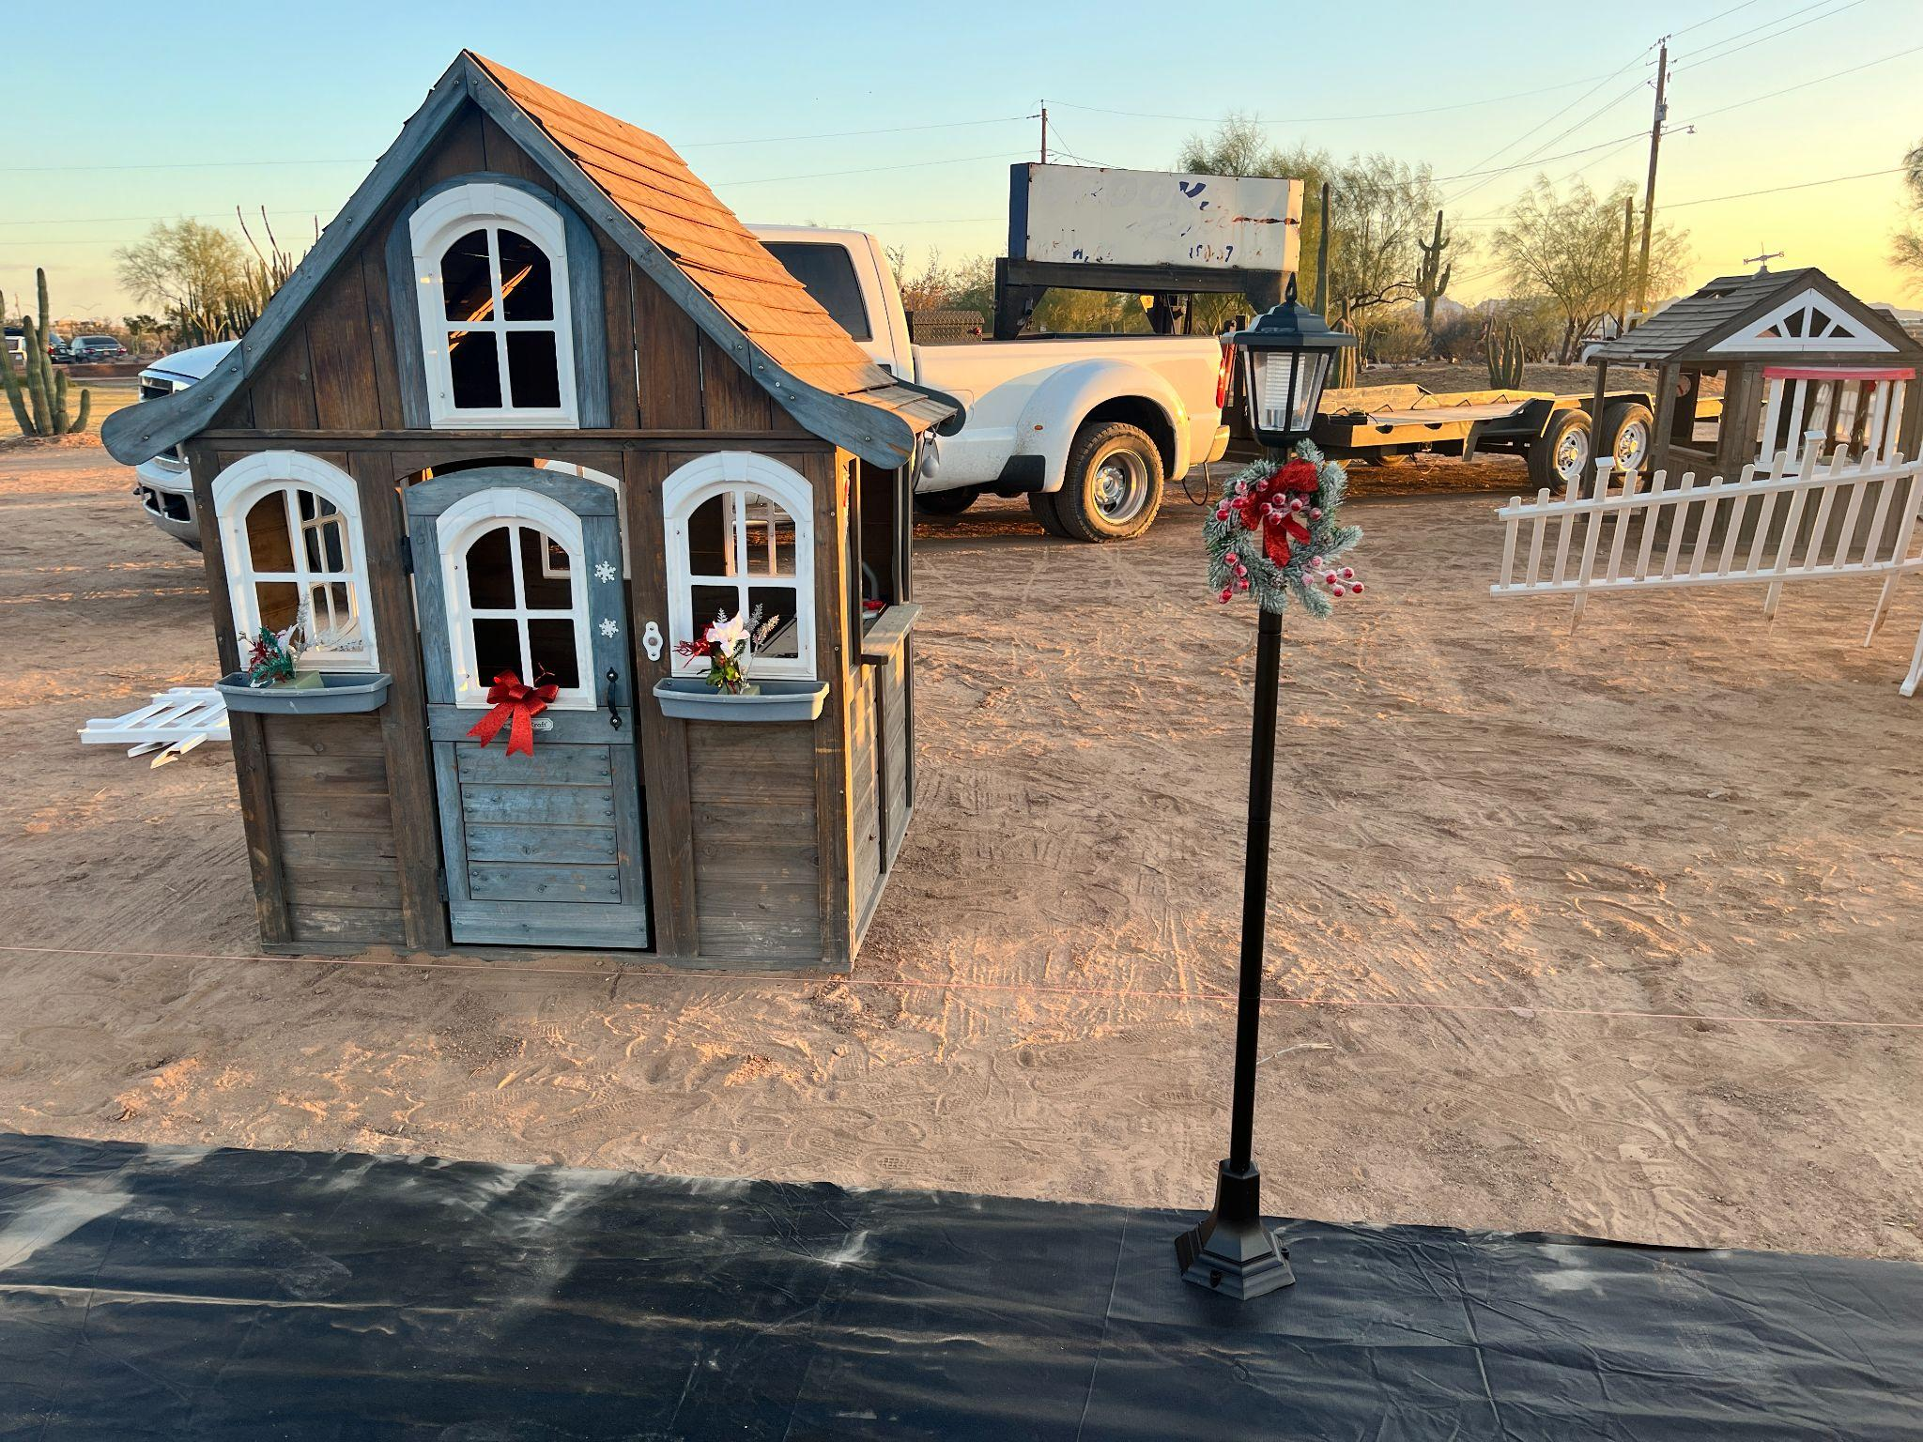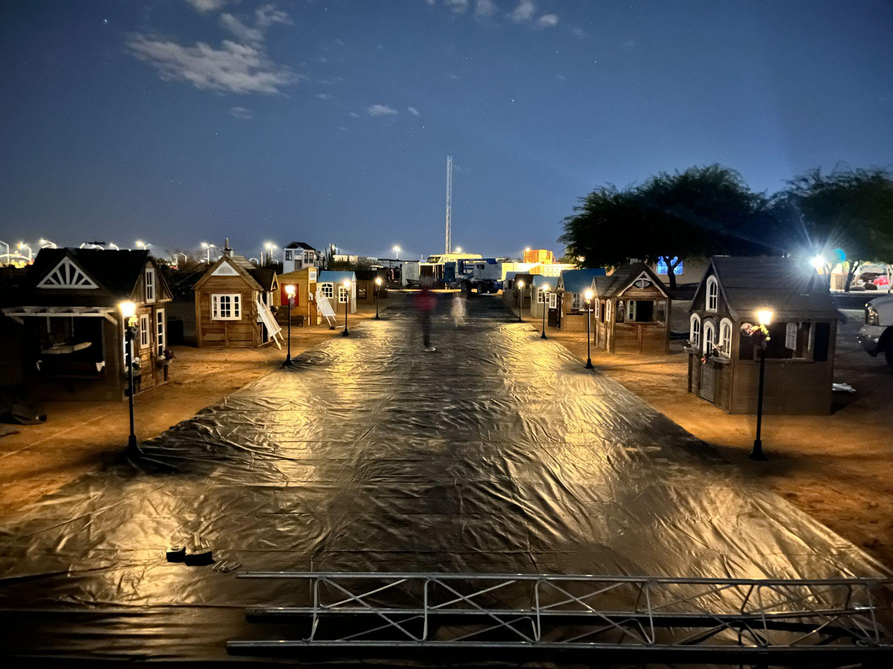
Lighted tree taking first string of lights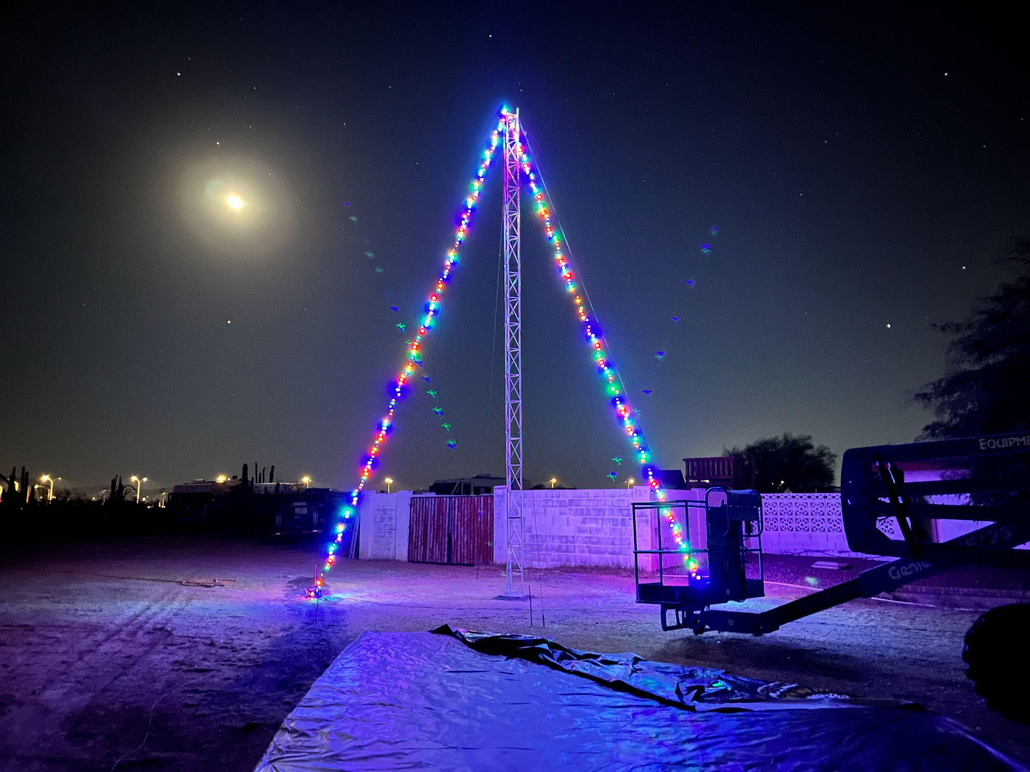
artificial turf has arrived, check to see how much detail it adds to the layout 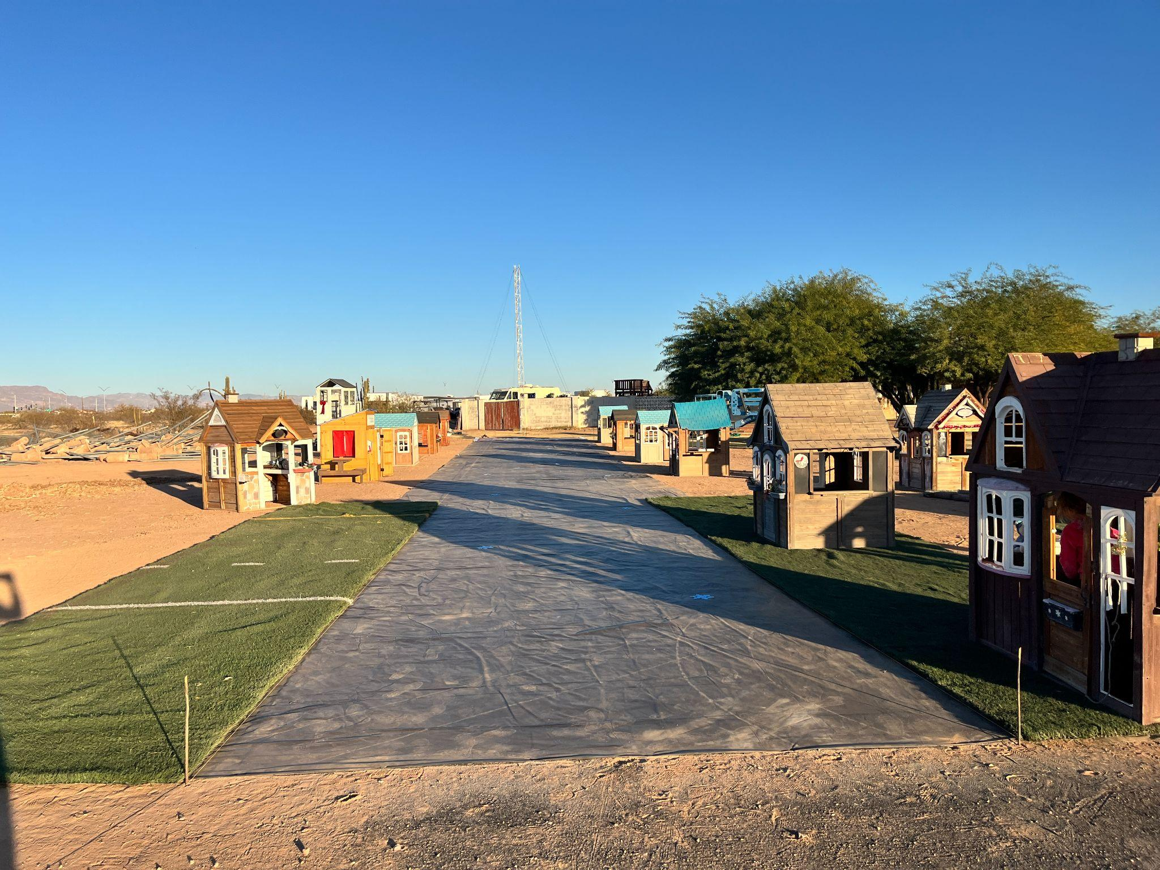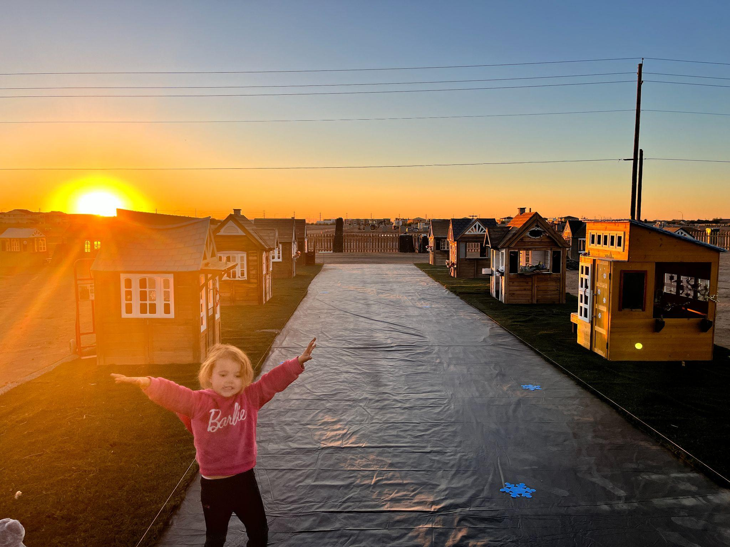
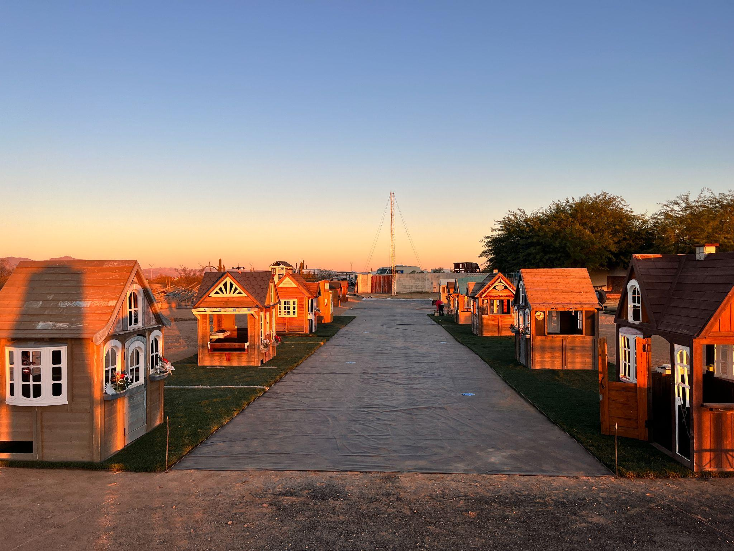
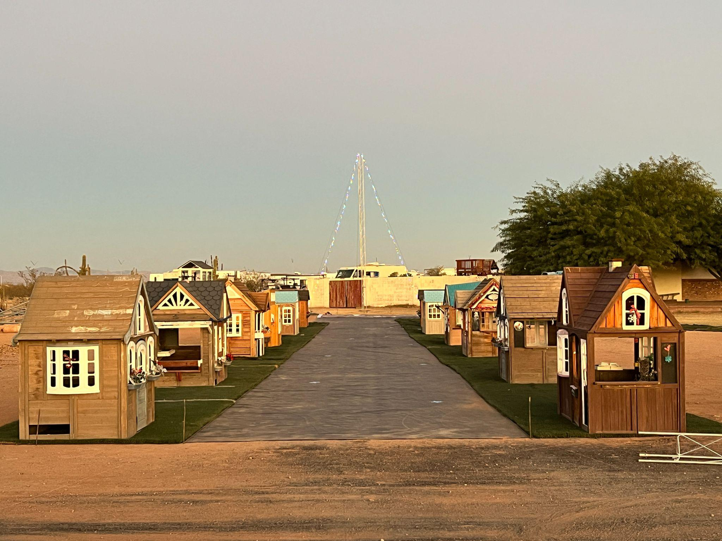
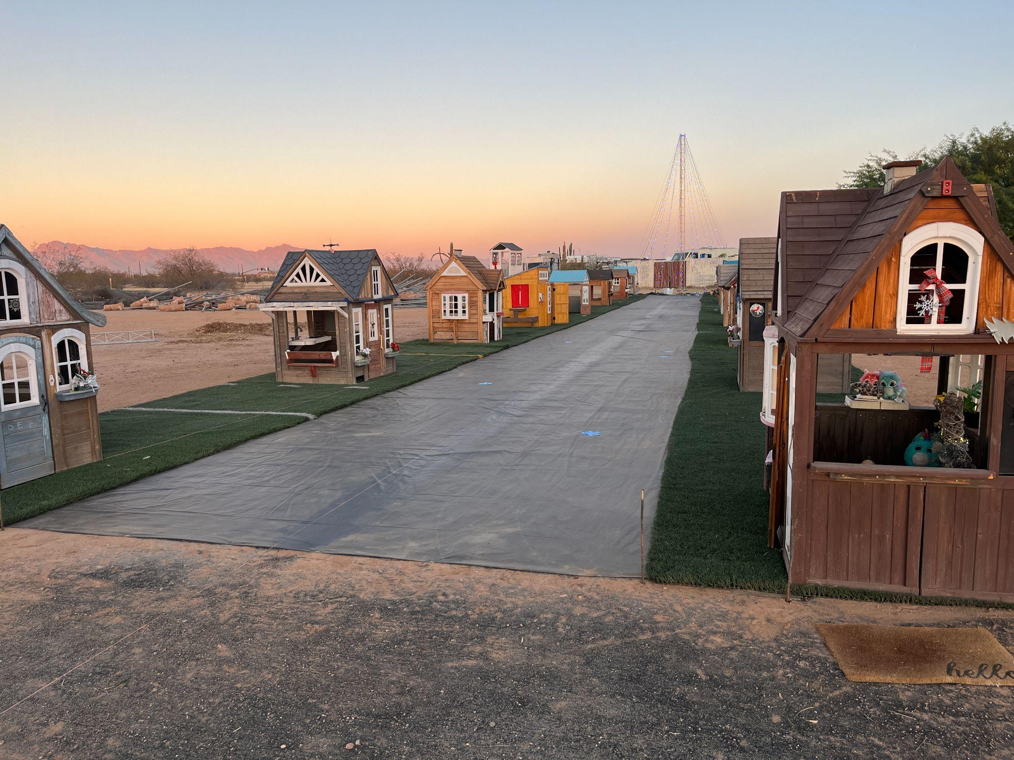

Adding the street lines for added detail and adding to the illusion of a forced perspective, the road narrows farther away giving it that long road illusion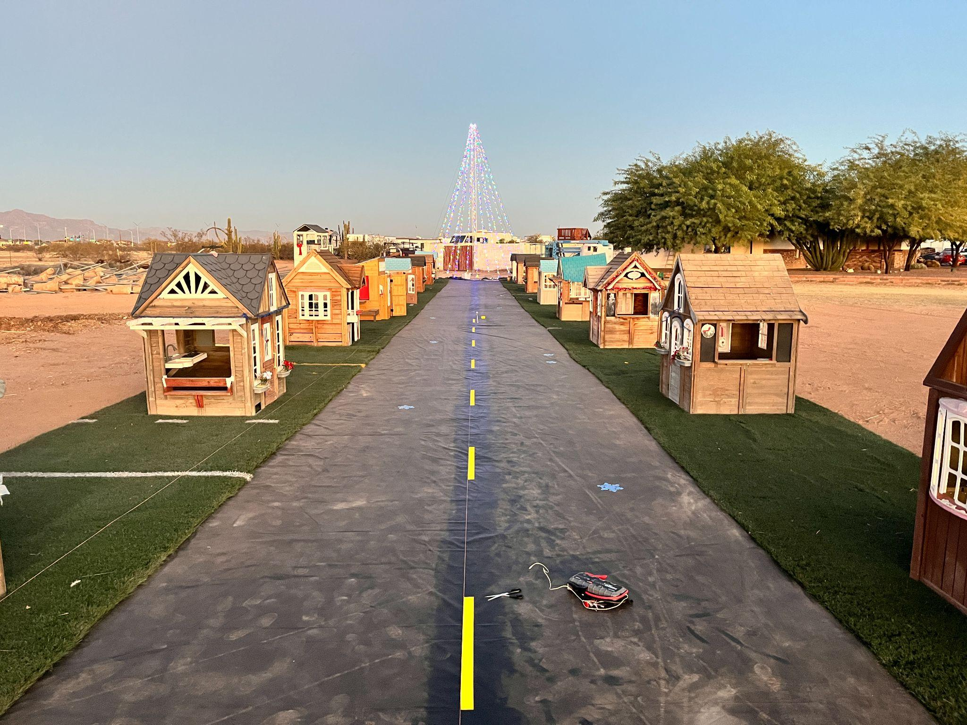
The lights have been installed on the houses the 30ft tree is complete the road is nice 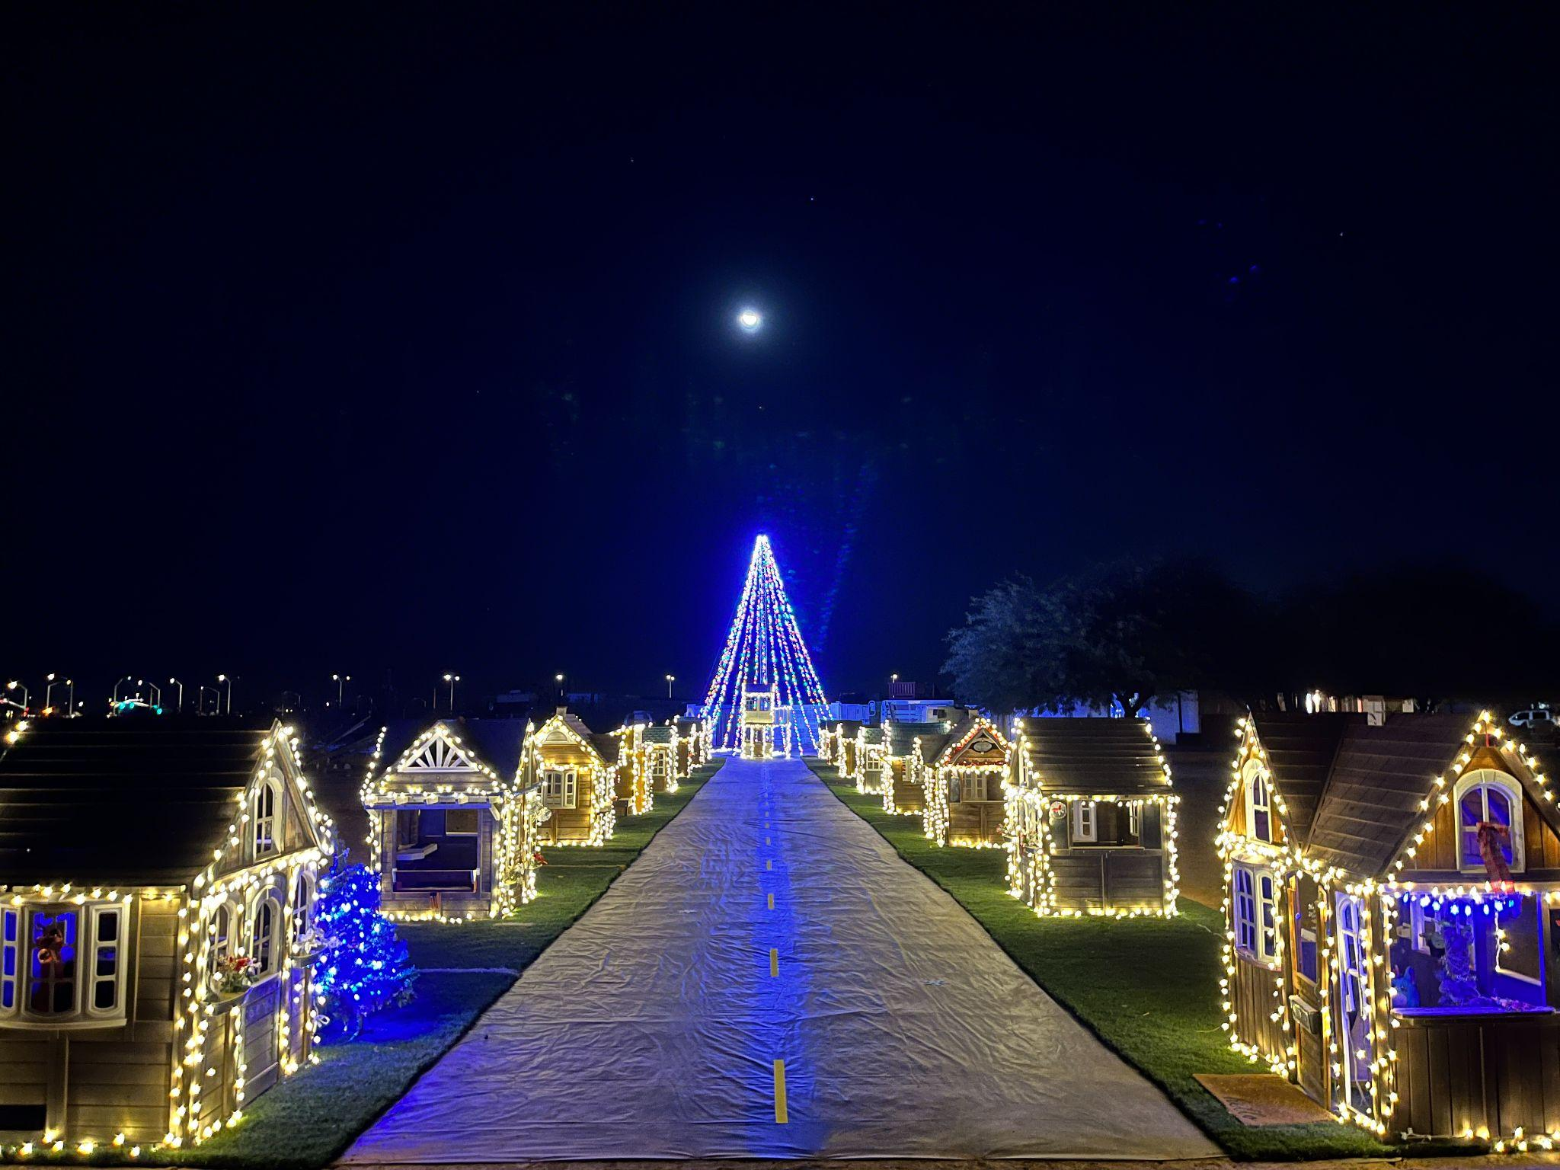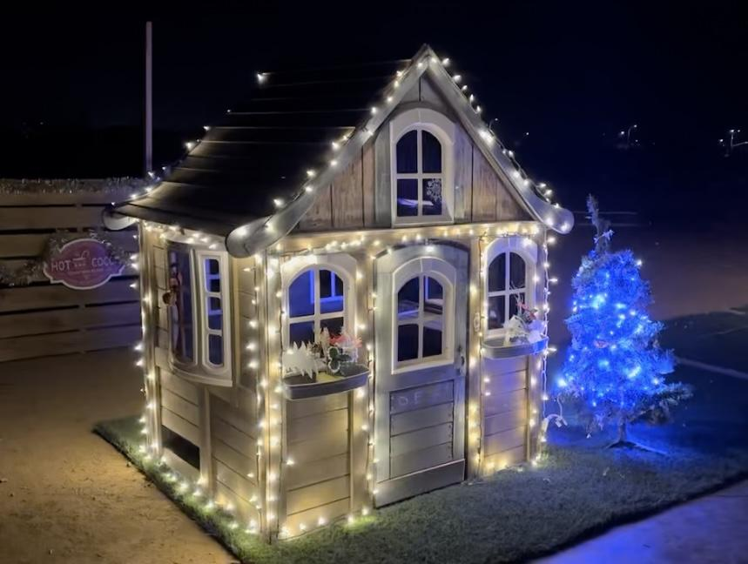
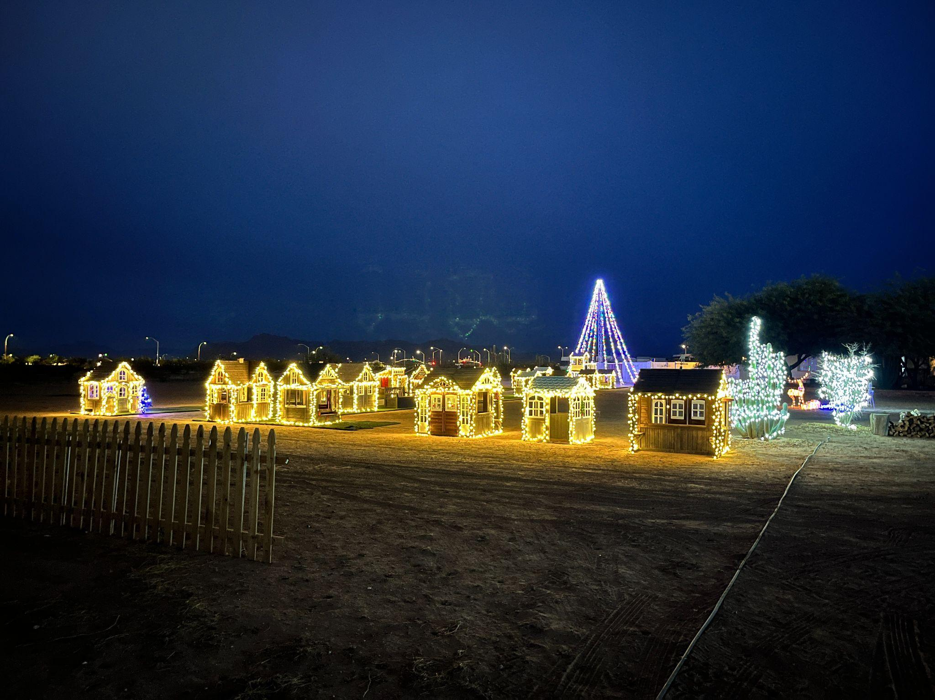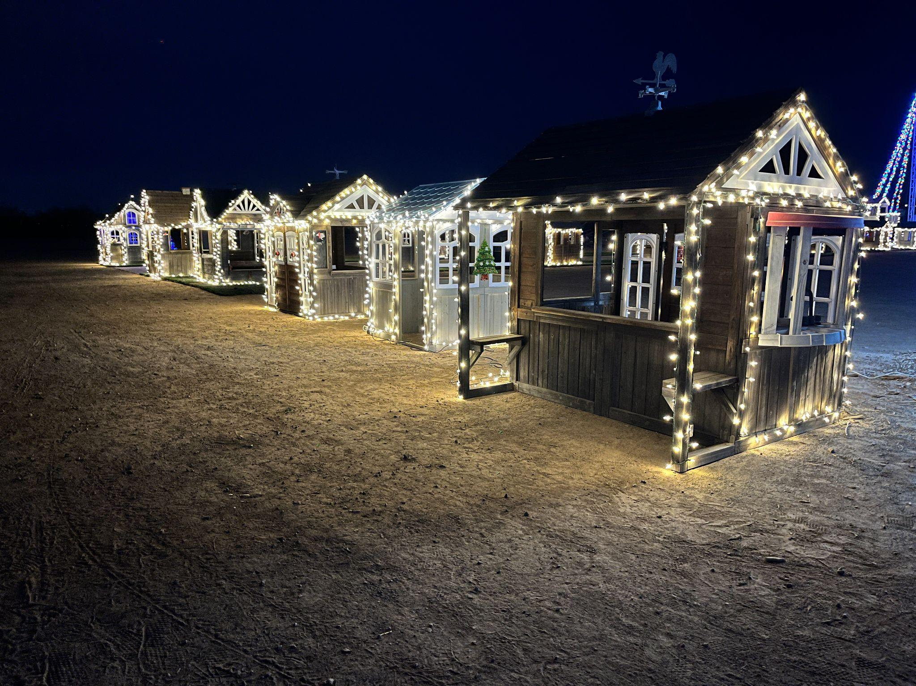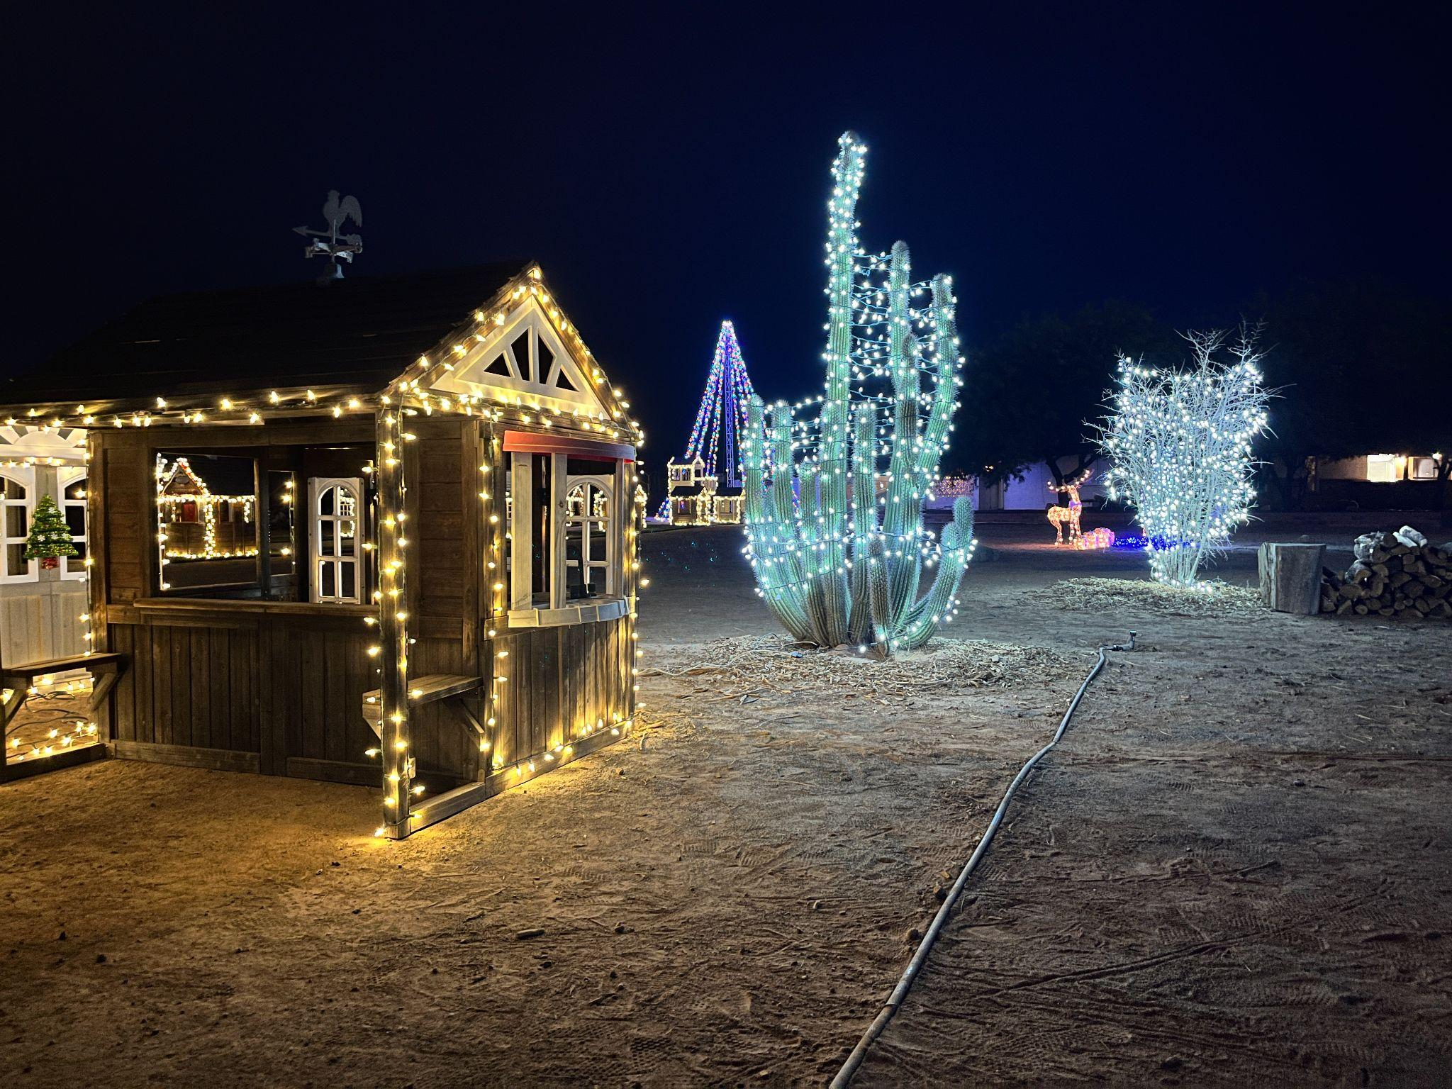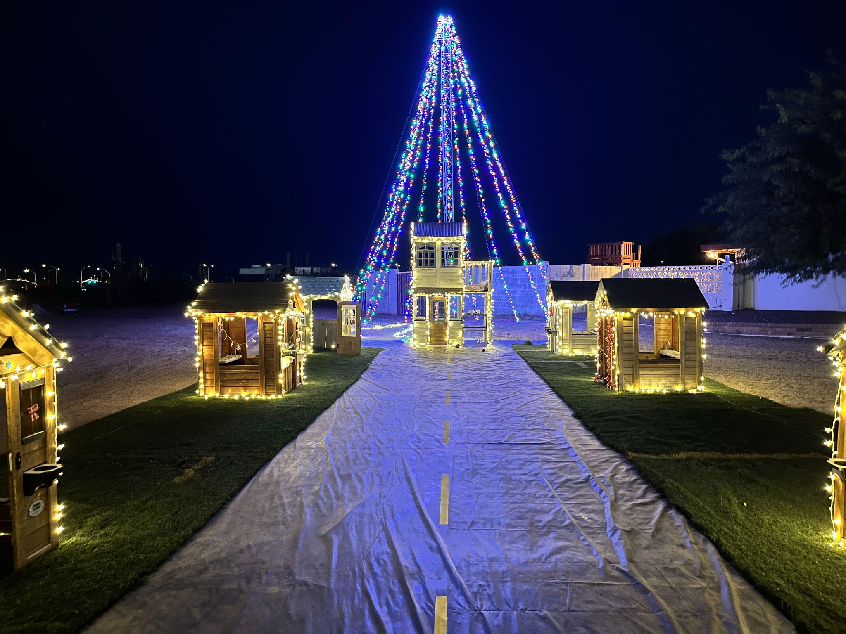
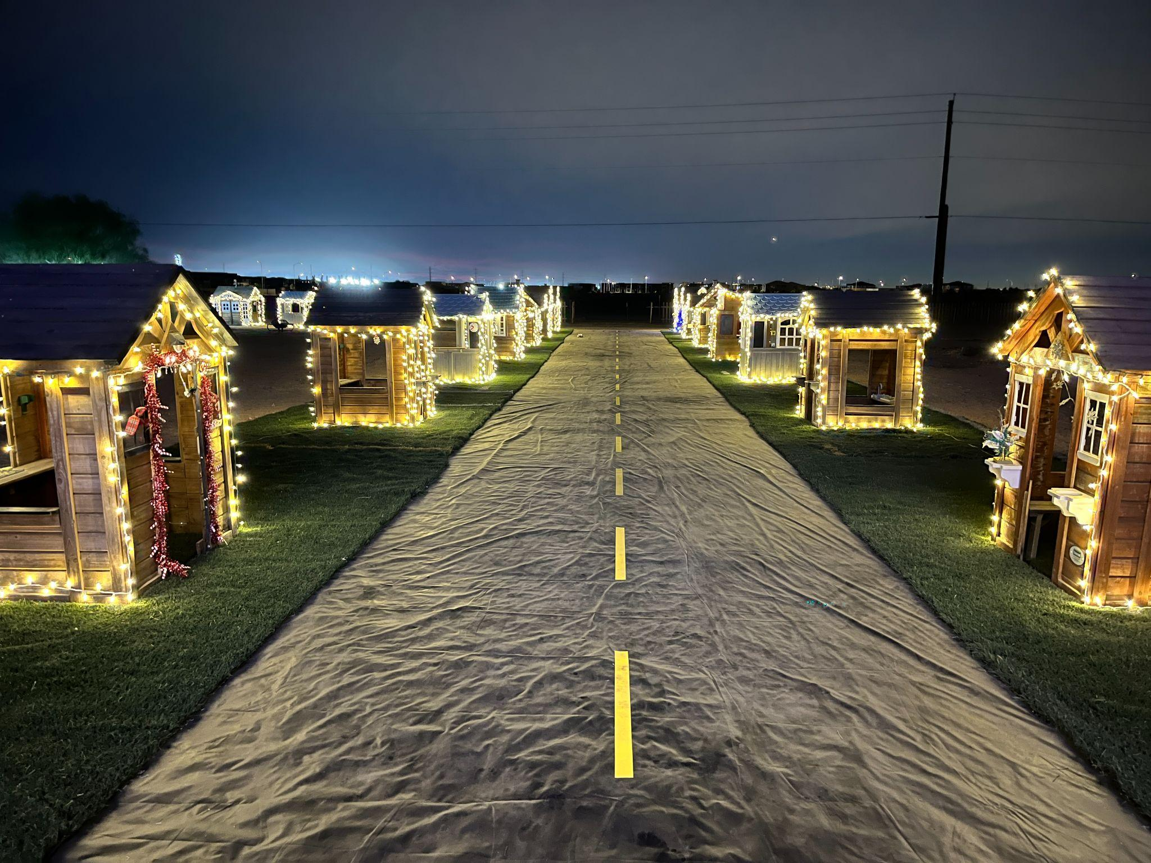

We stretched out fake asphalt ie; black vynil tarp for a working Main Street. We installed street lights, functioning stop lights which ended up not getting used, and even power wheels for kids to drive through the village.
By December 1st, 2024, Tiny Town opened its gates for the first time with:
- 30 miniature playhouses
- A “Blacktop” Main Street
- A two-story centerpiece playhouse
- A 30-foot lighted Christmas tree
- 80,000 lights
It wasn't just a Christmas display. It was an interactive wonderland where kids could run, play, and explore.

Year Two: Growing Through Storms (2025)
Arizona summers are brutal. We lost 5 playhouses to monsoon storms because we didn't have indoor storage. But we didn't quit—we adapted.
For 2025, Tiny Town evolved:

What We Added:
✅ 1,000 sq ft of magical waterfront space - Complete with a crossing bridge, creating an enchanting lakeside village atmosphere
✅ Tiny Town Railroad (TTRR) - 88 feet of functional track with a 5.5" scale ride-on Santa Fe train, complete with a scaled-down crossing signal that flashes as the train approaches
✅ 20 more Christmas trees
✅ Tree upgrade - Our main light tree grew from 30 feet to 45 feet (with an 80-foot tree planned for the future)
✅ Street signs - Main St, Big Tree Circle, Wonder Lane, and Trails Avenue were added this year
✅ Dedicated jingle - Our own Tiny Town theme song to be found on youtube
✅ Lighted entrance sign displaying the words “Tiny Town” with automatic timer-controlled "Open/Closed" display
✅ Official website and Instagram #TinyTownHolidayVillage
✅ Professional photographer to capture the magic
✅ Independent circuits on the tree for future choreographed light shows
We also condensed the layout to half the original footprint, making it more intimate and enchanting. The space used this year was the Christmas Tree forest from 2024, The addition of the waterfront with a crossing bridge transformed Tiny Town into a true village experience—kids love crossing the bridge and exploring both sides of the "lake." The railroad will eventually stretch 1,500 feet with multiple train cars and engines, in years to come.

Who We Are: A Family Mission
Tiny Town is designed, built, and operated by our family—inspired by our two children, ages 5 and 11. Every playhouse, every light, every detail is placed with purpose and care.
We didn't want another front yard where "Santa Claus threw up." We wanted something:
- Interactive - Kids play hide and seek, tag, and finders keepers
- Tasteful - No clutter, no inflatable overload—just thoughtful design
- Professional - Built with a commercial-level approach but kept family-owned
- Purposeful - Nothing is there just to be there
Tiny Town is for kids ages 2 to 11—a place where imagination runs wild and holiday magic feels real.

Our Inspiration: Standing on the Shoulders of Giants
In 2023, we visited the Pratt Brothers Christmas display at Legacy Sports Complex, and it changed everything. Their artistry, scale, and vision showed us what was possible. Though they've since moved to Rawhide in Chandler, from their original location at the legacy sports complex, we still visit for inspiration every year.
Tiny Town is our way of bringing that same sense of wonder to Mesa—in our own unique way.

The Build: A Labor of Love
Building Tiny Town takes:
- A 5-person crew working 8 hours a day
- One full month of setup
- Countless volunteers and paid helpers
- Endless problem-solving (like designing functional crossing signals and independent light circuits)
Every year, we refine the design. We have four major design phases planned, each adding new features and expanding the experience.

The Future: Tiny Town 2.0
Our dream is to move Tiny Town to a 2-acre commercial parcel we own on Main and Ellsworth, where we can:
- Welcome more visitors
- Create a permanent, year-round attraction
- Add even more interactive elements
- Expand the railroad
- Build Safety Town as originally envisioned
Until then, we're building Tiny Town better every year—one playhouse, one light, one train track at a time.

Visit Us
📍 Location: Google us “Tiny Town Holiday Village Mesa, AZ”
🎄 Grand Opening: Second week of December (follow us on Facebook and Instagram for dates)
💰 Admission: FREE—because every family deserves to experience holiday magic
👨‍👩‍👧‍👦 Best for: Kids ages 2-11 (and the young at heart!)

Join the Tiny Town Family
Follow us on Facebook and Instagram for updates, behind-the-scenes content, and grand opening announcements.
Tiny Town isn't just a Christmas display—it's a Mesa tradition in the making.

Welcome to Tiny Town. Where every house tells a story, every light sparks joy, and every visit creates memories that last a lifetime.

❤️ Built with love by a Midwest family who believes the magic of childhood should never grow old.

